**1.INTRODUCTION:**

**1.1.PROJECT OVERVIEW:**

Blockchain for food stores a complete history of data on a product journey from its origin through manufacturing, storage, transportation, and quality control processes to end consumers. Once recorded, food provenance data becomes immutable and can be accessed at any point.

1. **2.PURPOSE:**

Their blockchain food traceability system is used to:

* + - Instantly check for food fraud and product tampering
    - Identify and classify product waste in supply chains
    - Quickly identify food contamination issues that help with rapid product recalls
    - This article evaluates the application of blockchain technology to improve organic or fair-trade food traceability from “Farm to Fork” in light of European regulations. This study aims to shed light on the challenges in the organic food chain to overcome, the drivers for blockchain technology, and the challenges in current projects.

**2.LITERATURE SURVEY:**

1. **1.EXISTING PROBLEM:** 
   * Older software systems and paper-based record keeping make it difficult to trace data manipulation, especially when there are a limited number of people who have a copy or access to records. There are steps in the supply chain that don’t have an auditable trail of transactions and updates about the food data.
   * These consistent problems in the food supply chain reduce public trust in food safety. According to the “[Food Safety Supply Chain Vision Study,](https://www.undp.org/sites/g/files/zskgke326/files/2021-11/UNDP-Blockchain-for-Agri-Food-Traceability.pdf)” only 20% of global consumers place complete trust in companies to ensure food safety.

**2.2.REFERANCES:**

* J. Cheng and J. Ma, “Construction of food digital ID and intelligent monitoring platform based on blockchain traceability and GPS locationing,” in Proceedings of the 2021 5th International Conference on Electronics, Communication and Aerospace Technology (ICECA), pp. 1344–1347, Coimbatore, India, December 2021.

View at: [Publisher Site](https://doi.org/10.1109/ICECA52323.2021.9676143)

* K. S. Loke and O. C. Ann, “Food traceability and prevention of location fraud using blockchain,” in Proceedings of the 2020 IEEE 8th R10 Humanitarian Technology Conference (R10-HTC), pp. 1–5, Kuching, Malaysia, December 2020.

View at: [Publisher Site](https://doi.org/10.1109/R10-HTC49770.2020.9356999)

1. **3.PROBLEM STATEMENT DEFINITION:**

Currently, to provide transparency and access to the data, or control over their data. And Sometimes users ser (sellers/buyers) face issues while tracking down what happened to their food/product. A lot of times food supply got contaminated, spoiled, delayed, not issuing refunds as they stated or taking so much time to process it. So, there is no proper exchange platform for farmers to sell their products to buyers without any thirdparty database or human interference for claims. To no transparency or privacy for user data

1. **IDEATION & PROPOSED SOLUTION:**

* 1. **Empathy Map Canvas:**



* + - A food shortage, which has increased with the climate crisis, will be one of the biggest problems of the world, together with water scarcity, in the future and will damage the sustainability of the food supply system. With the effect of the COVID-19 pandemic, food resources are decreasing, and food prices are rising all over the world. The decrease in food sources increases the importance of food tracking even more….

* + - A smart contract structure that works in line with the system flow determined by using the VS Code interface was obtained. A sample smart contract screenshot over the developed application.
  1. **Ideation & Brainstorming:**

• A total of 0.038 s for latency was gathered with the proposed system, which is 435 times

better than Ethereum, one of the most popular blockchain infrastructures.

# • •

• A transmission per second value of 285, reception per second value of

335, and CPU load value of 19.22 are obtained with the proposed blockchainbased system.

# • •

• Through the proposed blockchain-based system to be established, suppliers that make

unfair price increases in the case of a food shortage, which will become a bigger problem in the coming periods due to the COVID-19 pandemic, will be prevented.

# • •

• It is the first study in which the live use of the blockchain-based food tracking system

is carried out and the satisfaction survey is carried out.

# • •

• A total of 75.31% of the users who use the application liked the interface of the application; 97.54% of the users stated that they found the application extremely

useful and that they would like to use it again in the future

1. **REQUIREMENT ANALYSIS:** 
   1. **Functional requirement**

The inherent features of blockchain, including immutability and transparency, create a dependable and secure system for **tracking food** products across the whole supply chain, ensuring total control over their traceability from the origin to the final consumer.

* 1. **Non-Functional requirements:** 
     + To make a system successful, it is very important to develop and consider the non-functional requirements properly [7]. On system can work just fine based on its functionality but can also fail for not handling the non-functional requirements (NFR) appropriately.
     + Non-functional requirements are product constraints or the features the system provides. They include constraints on timing, technology limits, and limitations imposed by standards. In certain cases, non-functional specifications refer to the device as whole systems or facilities, rather than individual device functions. This specific description, which describes something crucial in terms of what it is not, is not ideal, as many authors have discussed [8][9]. Our aim here is not to satisfactorily define NFRs but to explore their application to blockchain-based systems. NFRs can be treated as quality and the functional requirements can be recognized as an entity [10]. For example, a bus reservation system can be used to book seats using a secured transaction gateway. Here, booking the seats is functional requirements or entity of the system and security is the non-functional requirements or quality.

1. **PROJECT DESIGN:** 
   1. **Data Flow Diagrams & User Stories:**

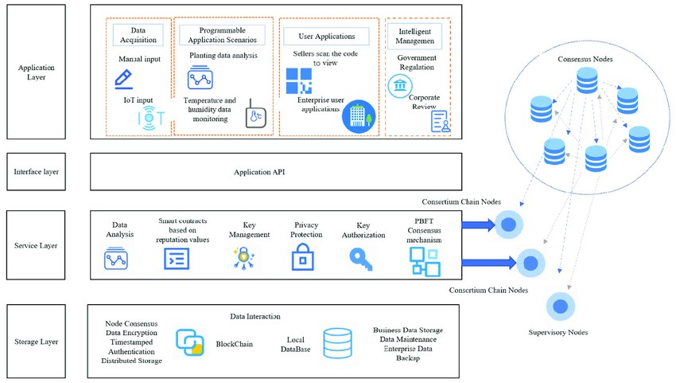

* 1. **Solution Architecture:**

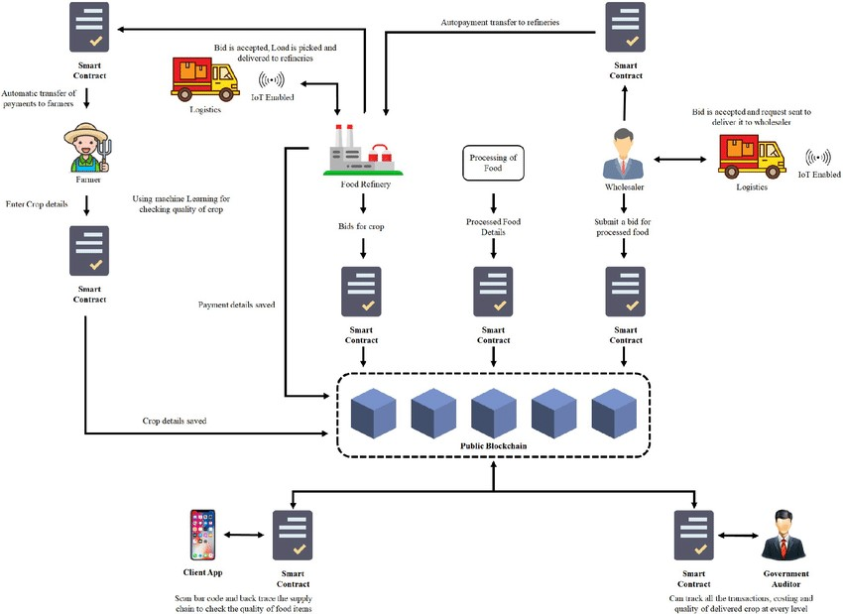

1. **PROJECT PLANNING AND SCHEDULING**

* 1. **Technical Architecture**

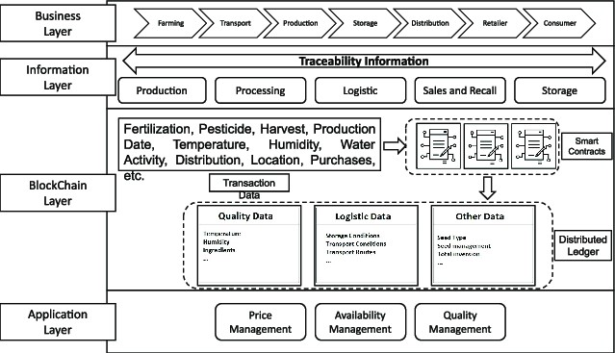

* 1. **Sprint planning & Estimation**

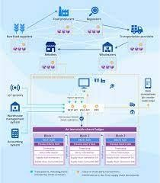

* 1. **Sprint Delivery Schedule**

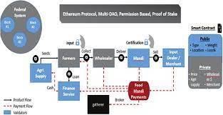

**7.CODING & SOLUTIONING**

* 1. **Feature 1**

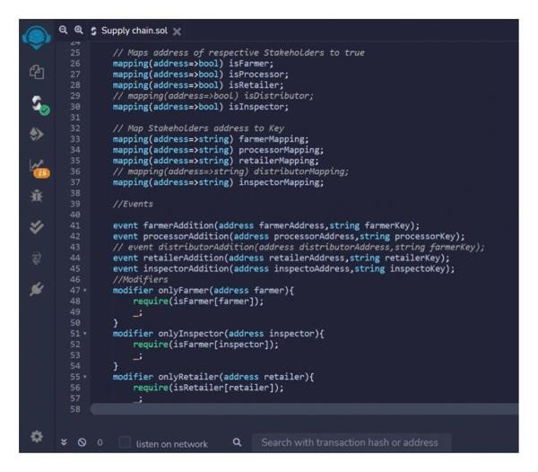

* 1. **Feature 2**

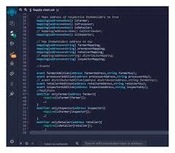

* 1. **Database schema**

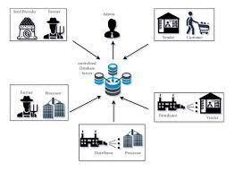

1. **PERFORMANCE TESTING**

* 1. Performance Metrics

* + - A blockchain-based food tracking system offers several advantages, but its performance can vary depending on the implementation.
    - Here are some considerations:Transparency: Blockchain enhances transparency in the food supply chain, allowing consumers to trace the journey of food products from farm to table. This can improve food safety and quality.Data Integrity.
    - Blockchain ensures data integrity and immutability, reducing the risk of fraud, counterfeiting, and tampering in the supply chain.Traceability: The system enables rapid traceability in case of food recalls or contamination incidents, which can save lives and reduce economic losses.
    - Efficiency: Blockchain can streamline supply chain processes by automating recordkeeping and reducing paperwork, leading to cost savings and improved performance.Real-time Updates.
    - Smart contracts in blockchain can automate transactions and agreements, improving the efficiency of payments and contracts between parties.Security: Blockchain is known for its strong security features, making it difficult for unauthorized parties to access or manipulate data.Scalability.
    - The performance of a blockchain-based food tracking system depends on its scalability. Large networks may face challenges in terms of speed and capacity, but these issues can be addressed with proper design.Interoperability.
    - Ensuring that different participants in the supply chain can use the blockchain system effectively is essential for performance and adoption.Environmental Impact.
    - However, the specific performance characteristics may depend on the implementation and scalability of the system.

1. **RESULT**

* 1. Output screenshots

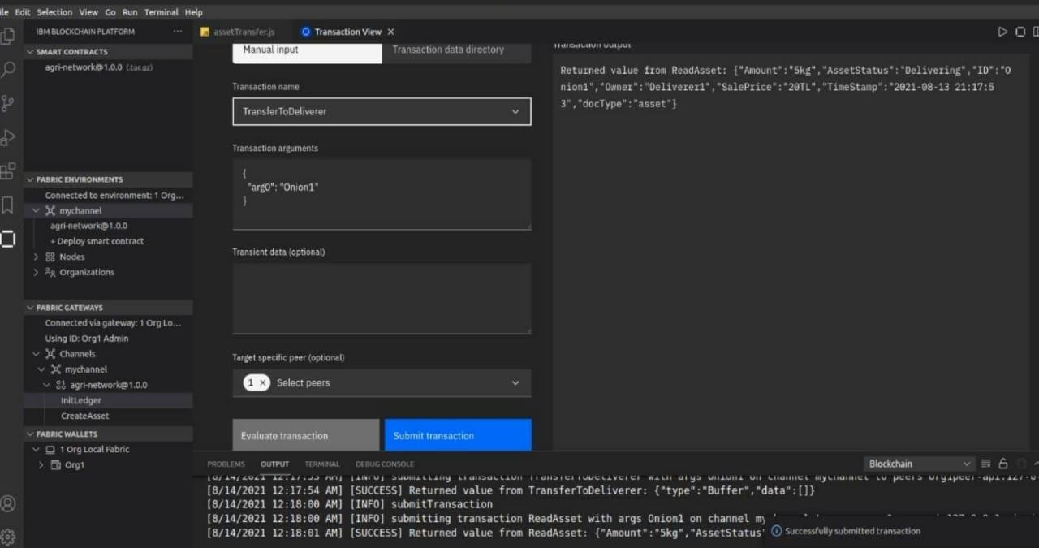

1. **ADVANTAGES AND DISADVANTAGES**

**Advantages:**

* + 1. Health Awareness: It helps individuals become more aware of their dietary habits, making it easier to identify and address areas for improvement in their diet.

* + 1. Weight Management: It can assist with weight loss or maintenance by allowing users to monitor their calorie intake and make informed choices.

* + 1. Nutritional Balance: Users can track their macronutrient and micronutrient intake, ensuring they get a well-balanced diet.

* + 1. Allergen and Sensitivity Management: It helps individuals with food allergies or sensitivities avoid specific ingredients.

* + 1. Goal Setting: Users can set nutrition and fitness goals and track their progress towards achieving them.

**Disadvantages:**

* + 1. User Compliance: These systems rely on users consistently inputting data, which can be time-consuming and may lead to inaccurate or incomplete information.

* + 1. Privacy Concerns: Users may have concerns about the privacy of their dietary and health information when using food tracking apps or systems.

* + 1. Overemphasis on Numbers: Some users become overly focused on calorie counting or specific nutrient values, which may lead to unhealthy eating habits or obsessions.

* + 1. Inaccuracy: The accuracy of food tracking can be compromised due to estimation of portion sizes, differences in food preparation methods, and variations in nutritional content.

* + 1. Obsessive Behavior: Constant tracking can lead to obsessive behavior or eating disorders in some individuals.

**12. FUTURE SCOPE**

1. Enhanced Transparency: Blockchain can provide consumers with even greater transparency regarding the origin, quality, and safety of food products. This could lead to more informed choices and increased trust in the food supply chain.

1. Supply Chain Optimization: Further integration of IoT (Internet of Things) devices and sensors with blockchain technology can lead to more efficient supply chains, reducing food waste and ensuring fresher products.

1. Global Food Security: Blockchain can contribute to global food security by enabling faster and more accurate responses to food recalls, reducing foodborne illnesses, and ensuring the availability of safe and nutritious food.

1. Smart Contracts: The use of smart contracts can automate payments, quality control, and agreements between participants in the food supply chain, reducing administrative overhead and improving efficiency.

1. Decentralized Systems: Decentralized blockchain networks can provide more resilience and security, especially in the face of cyber threats or system failures.

DEMO LINK: https://youtu.be/yk4XEv6hGSs?si=wu2KdoQeYlwCFfNj

GITHUB LINK: https://github.com/nithish3341/Food-Tracking-System.git